**VIETNAM NATIONAL UNIVERSITY – HOCHIMINH CITY**

**INTERNATIONAL UNIVERSITY**

**SCHOOL OF ELECTRICAL ENGINEERING**



**IOT-BASED APPLICATIONS FOR WATER**

**RESOURCE MONITORING SYSTEM**

BY

NGUYỄN TRUNG TÍN

A SENIOR PROJECT submitted to the School of Electrical Engineering in partial fulfillment of the requirements for the degree of Bachelor of Electrical Engineering

Ho chi minh city, vietnam  
2025

**IOT APPLICATIONS ON WATER**

**QUALITY MONITORING SYSTEM**

BY

**NGUYỄN TRUNG TÍN**

Under the guidance and approval of the committee, and approved by its members, this thesis has been accepted in partial fulfillment of the requirements for the degree.

Approved:

________________________________   
Chairperson

_______________________________   
Committee member

________________________________   
Committee member

________________________________   
Committee member

________________________________   
Committee member

# HONESTY DECLARATION

My name is Nguyễn Trung Tín. I would like to declare that, apart from the acknowledged references, this thesis either does not use language, ideas, or other original material from anyone; or has not been previously submitted to any other educational and research programs or institutions. I fully understand that any writings in this thesis contradicted to the above statement will automatically lead to the rejection from the EE program at the International University – Vietnam National University Hochiminh City.

Date:

Student’s Signature

Nguyễn Trung Tín

# TURNITIN DECLARATION

Name of Student:

Date:

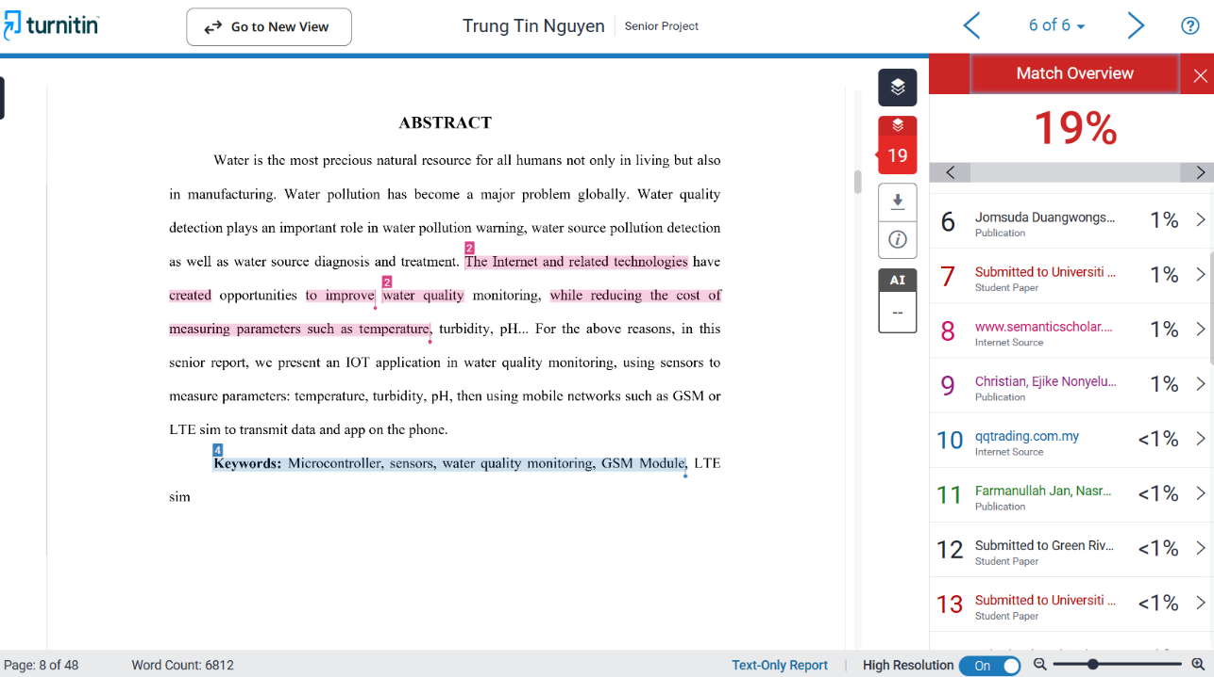

Advisor Signature Student Signature



Dr. Vương Quốc Bảo

# ACKNOWLEDGEMENT

I would like to express our sincere gratitude to all the individuals who have contributed valuable knowledge to the success and completion of this capstone. Firstly, I would like to express my appreciation to my advisor, Dr. Vương Quốc Bảo for his constructive feedback, encouragement, and guidance in completing this project with his valuable experience. Dr. Vương Quốc Bảo’s professional attitude and working style are an excellent model for us to follow. Secondly, I would also like to thank the professors, doctors, and masters of the Department of Electrical Engineering for imparting valuable knowledge to us. Furthermore, I would like to thank our friends, colleagues, and family for their unwavering support and valuable advice.

# TABLE OF CONTENTS

HONESTY DECLARATION 2

TURNITIN DECLARATION 3

ACKNOWLEDGEMENT 4

TABLE OF CONTENTS 5

LIST OF TABLES 8

LIST OF FIGURES 9

ABBREVIATIONS AND NOTATIONS 11

ABSTRACT 12

CHAPTER I. INTRODUCTION 13

1. 1. Theoretical background. 13

1. 1. 1. The importance of water resources and current challenges in Viet Nam. 13

1. 1. 2. IoT applications in daily life. 14

1. 1. 3. The reason for choosing the topic: Iot applications on water quality monitoring system. 15

1. 2. Goal and objectives. 16

1. 2. 1. Goal. 16

1. 2. 2. Objectives. 16

1. 3. The structure of the senior. 16

CHAPTER II. DESIGN SPECIFICATIONS AND STANDARDS 17

2. 1. Design Specifications and Standards. 17

2. 1. 1. System overview. 17

2. 1. 2. Functional requirements. 17

2. 1. 3. Wifi standard. 17

2. 1. 4. GSM standard. 18

2. 2. Realistic constraints. 18

2. 2. 1. Hardware. 18

2. 2. 2. Software. 19

CHAPTER III. PROJECT MANAGEMENT 20

3. 1. Budget and Cost Management Plan. 20

3. 2. Project schedule. 21

CHAPTER IV. LITERATURE REVIEWS 22

4. 1. Existing IoT based water quality monitoring systems. 22

4. 1. 1. First article: Design & Implementation of Water Quality Monitoring & Notification System [9]. 22

4. 1. 2. Second article: Design and Implementation of a Smart Water Monitoring System (IoT) Using Arduino Microcontroller [10]. 24

4. 1. 3. Third article: Real-time Water Quality Monitoring and Notification System for Aquaculture [11] 26

4. 2. Proposed methodology for this senior project. 27

CHAPTER V. METHODOLOGY 29

5. 1. Hardware design. 29

5. 1. 1. Temperature sensor. 29

5. 1. 2. pH sensor. 30

5. 1. 3. Turbidity Sensor. 31

5. 1. 4. Ultrasonic sensor. 32

5. 1. 5. Wifi module. 33

5. 1. 6. GSM shield module. 33

5. 1. 7. Power Supply. 34

5. 2. Software design. 34

5. 2. 1. Drawing the schematic. 34

5. 2. 2. Blynk. 35

5. 2. 3. Programming for all systems. 36

CHAPTER VI. RESULTS 38

6. 1. Hardware design. 38

6. 2. Software design. 39

6. 2. 1. Blynk app. 39

6. 2. 2. Prototype product. 40

6. 2. 3. System boot. 40

6. 3. Evaluate the system performance in different environments. 43

6. 3. 1. Case 1: Acidic environment: pH about 4. 44

6. 3. 2. Case 2: Neutral environment: pH about 6. 46

6. 3. 3. Case 3: Basic environment: pH about 9. 47

6. 3. 4. Conclusion 48

CHAPTER VII. CONCLUSIONS AND FUTURE WORK 49

7. 1. Conclusions. 49

7. 2. Future work. 49

REFERENCES 51

# LIST OF TABLES

**Table 5. 1** Technical parameters of pH sensor **[13].** 31

**Table 6. 1** pH correction package specifications 43

# LIST OF FIGURES

**Figure 4. 1** Block diagram showing connections of all components **[9].** 23

**Figure 4. 2** prototype of water quality monitoring & notification system **[9]**. 23

**Figure 4. 3** Block diagram of the project **[10]**. 24

**Figure 4. 4** Flow chart diagram of the project **[10]**. 25

**Figure 4. 5** Image of the final project work **[10]**. 26

**Figure 4. 6** Conceptual Diagram of Water Quality Monitoring and Notification System **[11].** 27

**Figure 4. 7** The major components of the system **[11]**. 27

**Figure 5. 1** Block diagram of the system. 29

**Figure 5. 2** Dallas temperature sensor (DS18B20). 30

**Figure 5. 3** Analog PH sensor. 30

**Figure 5. 4** Turbidity sensor. 32

**Figure 5. 5** Ultrasonic sensor (HC-SRF04). 32

**Figure 5. 6** The ESP8266 Wi-Fi module. 33

**Figure 5. 7** SIM800L. 33

**Figure 5. 8** DC Voltage Reduction Circuit LM2596. 34

**Figure 5. 9** Schematic of the system on Proteus software. 35

**Figure 5. 10** The Flowchart of IoT Water Monitoring System. 37

**Figure 6. 1**. Hardware system. 38

**Figure 6. 2** Blynk application interface on smartphone. 39

**Figure 6. 3** Entire system 40

**Figure 6. 4** LCD display. 41

**Figure 6. 5** SIM800L module in operating state. 41

**Figure 6. 6** SIM connection success notification and sensor data. 41

**Figure 6. 7** ESP32 module successfully connects to the Wi-Fi network. 42

**Figure 6. 8** Blynk application interface displaying sensor parameters. 42

**Figure 6. 9** pH correction package. 43

**Figure 6. 10** Hardware system when operating with low pH water samples. 44

**Figure 6. 11** Blynk interface shows pH measurement result is 4.03 along with other indicators 45

**Figure 6. 12** The litmus test results showed that the pH was at 4. 45

**Figure 6. 13** Hardware system when operating with pH = 6.83 water samples. 46

**Figure 6. 14** Blynk interface shows pH measurement result is 6.83 along with other indicators 46

**Figure 6. 15** The litmus test results showed that the pH was at 6. 47

**Figure 6. 16** Hardware system when operating with high pH water samples. 47

**Figure 6. 17** Blynk interface shows pH measurement result is 9.21 along with other indicators. 48

**Figure 6. 18** The litmus test results showed that the pH was at 10. 48

# ABBREVIATIONS AND NOTATIONS

NTU: Nephelometric Turbidity Units

GSM: Global System for Mobile Communications

GPRS: General Packet Radio Service

# ABSTRACT

Water is the most precious natural resource for all humans not only in living but also in manufacturing. Water pollution has become a major problem globally. Water quality detection plays an important role in water pollution warning, water source pollution detection as well as water source diagnosis and treatment. The Internet and related technologies have created opportunities to improve water quality monitoring, while reducing the cost of measuring parameters such as temperature, turbidity, pH... For the above reasons, in this senior report, we present an IOT application in water quality monitoring, using sensors to measure parameters: temperature, turbidity, pH, then using mobile networks such as GSM or LTE sim to transmit data and app on the phone.

**Keywords:** Microcontroller, sensors, water quality monitoring, GSM Module, LTE sim

# INTRODUCTION

In this chapter, there are three main parts which are theoretical background, goal and objectives, and structure of the senior report.

## Theoretical background.

This section will be divided into 3 small parts including: first of all is the importance of water resources and current challenges in Viet Nam, the second is IoT applications in daily life and the reason for choosing the topic.

### The importance of water resources and current challenges in Viet Nam.

Water covers ¾ of the earth and is a valuable resource for human life. 70% of the Earth's surface is covered by water, but only 2.5% of the world's water is fresh water, while 97.5% is ocean water **[1]**. Of this, 0.3% of the world's fresh water is in rivers and lakes; 30% is groundwater, the rest is on glaciers and icebergs **[1]**. 70% of the world's water is used for agriculture, 22% for industry and 8% for daily life **[2]**.

Industrialization, modernization, and climate change are putting pressure on both the quality and quantity of water resources. Water depletion, increased demand for clean water, and declining water quality are challenges facing humanity. Currently, more than 2.6 million people worldwide do not have access to basic sanitation and nearly 1 billion people do not have access to clean water **[2]**. Every 20 seconds, a child dies from diseases related to lack of clean water and adequate sanitation **[2]**. A recent report by the World Bank estimates that by 2030, human demand for water will exceed supply by 40% **[1].**

Currently, many large cities, typically Hanoi and Ho Chi Minh City, are still lacking clean water for daily life. Groundwater resources are being exploited uncontrollably, and drilling wells to get underground water is rampant, not only causing loss and waste but also potentially polluting that water source. Furthermore, due to not fully understanding the importance of water resources, all over the country, there are landfills, burial sites, and waste treatment facilities that are not carried out in accordance with regulations and environmental protection procedures, allowing leachate to seep into underground water sources and overflow into saltwater sources.

With the increasingly serious scarcity and pollution of water resources, the need for monitoring and managing water quality has become more urgent than ever. Current challenges require advanced technological solutions to monitor and protect precious water resources. Therefore, the application of water quality monitoring technology, especially IoT systems with smart sensors, not only helps to measure accurately but also provides real-time data, supporting timely detection and handling of water pollution and depletion problems. This solution will be the key to protecting water resources, ensuring safety and quality of life for the community.

### IoT applications in daily life.

The development of the Internet of Things has a strong impact on production, business, life and society in many fields: infrastructure management, healthcare, construction and automation monitoring **[3]**. The Internet of Things (IoT) is a rapidly expanding computer trend that enables objects or gadgets linked to the internet to have the ability to gather, process, and share information **[4]**. The internet of things is known as a technology that has demonstrated its existence as a network of machines or gadgets that can communicate with one another **[4]**.

Over the past few years, IoT has become one of the important technologies. IoT helps people live and work smarter, as well as be completely proactive in life. In the application of water quality monitoring, IoT plays an important role by providing automatic and intelligent monitoring solutions. A wireless sensor network-based real-time drinking water water quality monitoring system was introduced in **[5]**. The system sent the user an SMS alert with the water quality metrics, including temperature, turbidity, and pH, using a Zigbee module. The identical parameters from **[5]** were examined in **[6]**, relayed to the user via an XBee wireless module, and shown on the LCD. When the parameters are dangerous, a buzzer will sound an alert. A real-time mobile water temperature monitoring system that could help aquaculture farmers improve their operations was described in **[7]**. The Raspberry Pi served as the microcontroller, and it was connected to the mobile device through the internet. Finally, a survey of water quality monitoring with wireless sensor networks (WSN) was provided in **[8]**. The results show how dependent the project is on the mobile network.

### The reason for choosing the topic: Iot applications on water quality monitoring system.

The International Standard Organization defines water quality monitoring as a process for collecting, measuring, and further documenting or indicating different water features, with the objective of evaluating compliance with specified water quality objectives **[4]**. Water quality describes the overall biological, physical, and chemical composition of the water. Thus, evaluating drinking water quality requires monitoring various physical, chemical, and biological parameters. This is where the application of IoT in water quality monitoring becomes crucial, allowing for continuous, accurate, and efficient data collection and analysis, providing the basis for informed decision-making in water management.

In this project, a device was developed to measure water quality indicators, including pH, temperature, and turbidity, with higher accuracy and efficiency than existing instruments. The device integrates a pH sensor, a temperature sensor, and a turbidity sensor, connected to an Arduino microcontroller and a Wifi module, allowing real-time data transmission to mobile devices via SMS and the Blynk app. Users can easily monitor water quality on their smartphones and receive immediate alerts when abnormalities are detected. Thanks to the ability to continuously collect data and send real-time notifications, the system helps improve the efficiency of water quality monitoring, while reducing costs and optimizing the handling process when problems occur.

## Goal and objectives.

### Goal.

Design and development of a water quality monitoring system that uses sensors and a microcontroller to measure key parameters such as temperature, pH, and turbidity. Then send and display the data on web and mobile applications.

### Objectives.

1. Review the existing techniques that use IoT to monitor water quality.
2. Design and implement an IoT-based system to measure water quality parameters such as temperature, pH and turbidity. Then, a cloud server will be used to store data for tracking in web or mobile applications.
3. Evaluate the system performance in different environments.

## The structure of the senior.

The content of this senior is divided into seven chapters. The chapter I provides about theoretical background, and it also presents the goals and objectives of the senior. The second chapter is design specification and standards. The third chapter provides a budget and cost management plan, a project management plan, tasks to be performed, and specific timelines for each task, all displayed in a Gantt chart. Next are the references related to our project, providing knowledge and solutions for developing the water quality monitoring system presented in Chapter IV. The fifth chapter provides the methodology for achieving the objectives. Chapter VI presents the results. Finally, chapter 7 discusses conclusions, implications, strengths, weaknesses and effectiveness of the system and future development prospects.

# DESIGN SPECIFICATIONS AND STANDARDS

This chapter will describe in detail the hardware and software design of the IoT water quality monitoring system. Establish a clear framework for the design process, ensuring that the system architecture, functional requirements and practical constraints necessary for successful operation are met. The system uses microcontrollers, various sensors to collect data, connects to WiFi and GSM, and transmits information to users over the network.

## Design Specifications and Standards.

### System overview.

The water quality monitoring system uses Arduino UNO and ESP8266 to connect temperature, pH, and turbidity sensors to WiFi and GSM networks. The data will be transmitted to the Blynk application, where users can monitor the parameters in real time.

The index sensors include: DS18B20 sensor (temperature measurement), pH sensor, turbidity sensor.

The SIM800L module is used for communication via GSM, ensuring monitoring capability in the absence of WiFi.

### Functional requirements.

The system must measure and transmit data on water quality parameters such as pH, temperature, and turbidity.

Send alerts to users if there are abnormal parameters via SMS and Blynk application.

### Wifi standard.

The system uses the ESP8266 WiFi module, supporting the IEEE 802.11 b/g/n WiFi standard. This WiFi standard allows data transmission at speeds up to 150 Mbps in the 2.4 GHz band. This is a popular standard and is suitable for IoT applications thanks to its stable connection and good coverage in indoor and outdoor environments. In addition, this module supports security protocols such as WPA/WPA2, ensuring the safety of transmitted data.

### GSM standard.

The system uses the SIM800L module, supporting the GSM (Global System for Mobile Communications) standard. This is a popular mobile network standard, operating on the 850 MHz, 900 MHz, 1800 MHz, and 1900 MHz bands, allowing connections in most countries around the world.

The GSM standard allows the system to send and receive data (such as SMS messages or notifications) at the basic speed of the GPRS (General Packet Radio Service) network. This ensures that the device still operates effectively even without WiFi, providing stable data transmission in remote areas or without a fixed Internet connection.

## Realistic constraints.

### Hardware.

Arduino UNO R3: Central microcontroller to collect data from sensors and control SIM800L and ESP8266 modules.

ESP8266 NodeMCU: Used to connect to Blynk mobile application via WiFi network.

DS18B20 sensor: Temperature sensor using OneWire standard to measure water temperature.

Turbidity sensor: Sensor measures the level of turbidity of water, helping to determine the pollution status and clarity of water.

pH sensor: Measures the pH of water to determine acidity/base.

SIM800L module: Used to send SMS notifications via GSM network, when there is no WiFi connection.

LCD 2004: Used to display measured values directly on site.

### Software.

We will use the C programming language. All code will be developed on Arduino IDE software. There are main libraries we use: Wire.h, SoftwareSerial.h, OneWire.h, DallasTemperature.h, LiquidCrystal.h, ESP8266WiFi.h, BlynkSimpleEsp8266.h.

# PROJECT MANAGEMENT

This chapter shows the project budget, cost management plan and project schedule.

## Budget and Cost Management Plan.

Table 3.1 provides a description of how the project costs are managed. Provides detailed information on the costs of all components and equipment required for the project.

**Table 3. 1** Cost management plan.

|  |  |  |  |
| --- | --- | --- | --- |
| Numbers | Component | Amount | Cost |
| 1 | Arduino UNO R3 | 1 | 99.000 VND |
| 2 | ESP8266 (Node MCU) | 1 | 95.000 VND |
| 3 | LCD2004 | 1 | 82.000 VND |
| 4 | SIM800L | 1 | 85.000 VND |
| 5 | Temperature sensor | 1 | 20.000 VND |
| 6 | pH sensor | 1 | 1.100.000 VND |
| 7 | Turbidity sensor | 1 | 120.000 VND |
| 8 | Ultrasonic sensor | 1 | 30.000 VND |
| 9 | Other components |  | 400.000 VND |
| 10 | Total |  | 2.031.000 VND |

## Project schedule.

The project progress and timeline to achieve the goals and objectives are shown in the gantt chart below

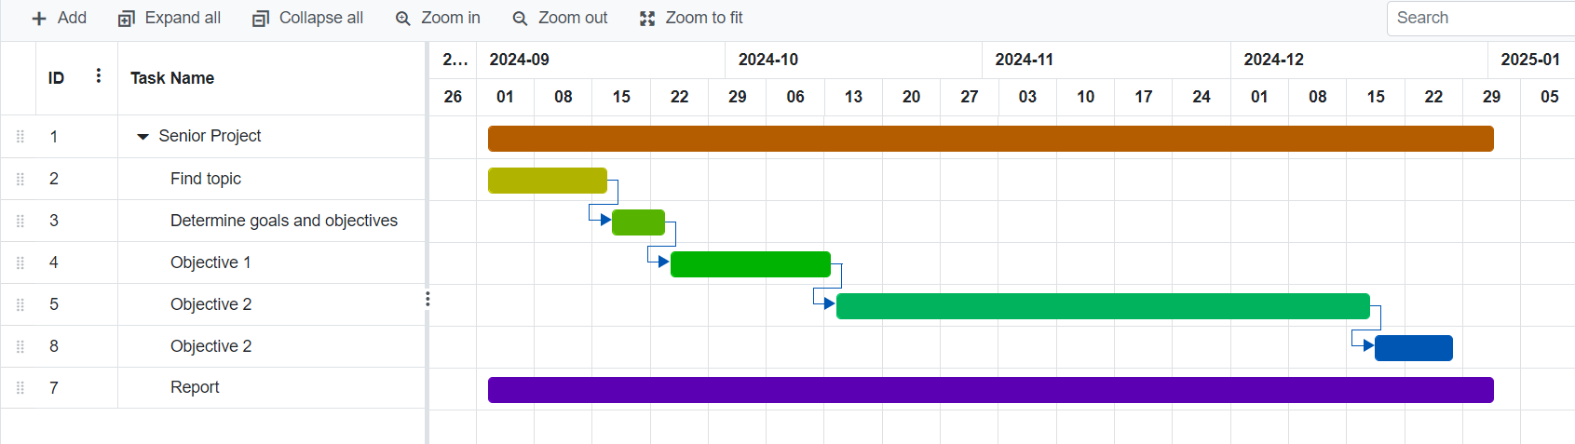

**Figure 3. 1** Project schedule.

# LITERATURE REVIEWS

Based on section **1.2.2** the first objective is to study existing techniques using IoT to monitor water quality. To achieve this objective, we have divided the literature review into two main sections: **4.1** Existing IoT based water quality monitoring systems and **4.2** Proposed methodology to be applied in this senior project. Below are details of each part.

## Existing IoT based water quality monitoring systems.

Recently, with the advancement of Internet Things (IoT), several IoT based solutions have been introduced for water quality monitoring, I found 3 articles on how to develop a system to monitor water parameters.

### First article: Design & Implementation of Water Quality Monitoring & Notification System [9].

This paper presents a low-cost IoT-based solution for real-time water quality monitoring. The system uses sensors to measure pH, turbidity and temperature parameters, integrated with Arduino Mega microcontroller for data collection and processing. The results are displayed locally on the LCD screen and SMS notifications are sent via GSM module (SIM900A), helping users receive instant alerts when parameters are abnormal.

#### Hardware.

The hardware devices used include:

* Turbidity Sensor
* Temperature sensor
* PH sensor
* Ultrasonic sensor
* Arduino Mega Board
* GSM shield module
* LCD display

#### Block diagram and prototype of system.

Figure 4.1 shows the connection diagram of the components.

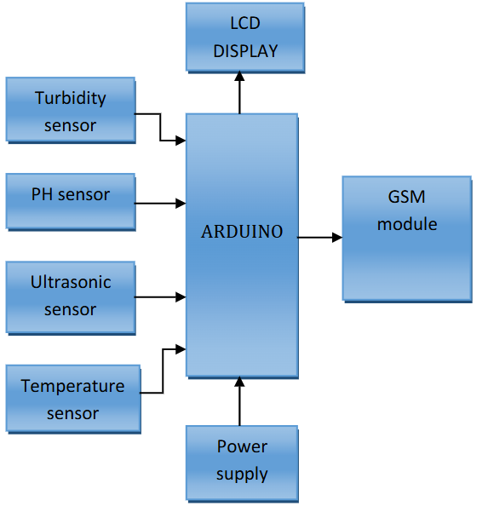

**Figure 4. 1** Block diagram showing connections of all components **[9].**

Figure 4.2 is the prototype of the product.

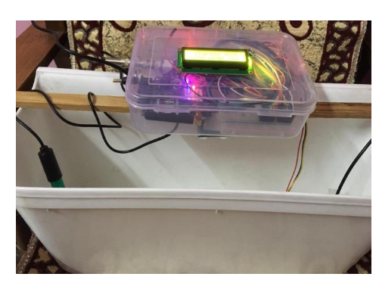

**Figure 4. 2** prototype of water quality monitoring & notification system **[9]**.

### Second article: Design and Implementation of a Smart Water Monitoring System (IoT) Using Arduino Microcontroller [10].

This study presents a smart water monitoring system using IoT technology, focusing on real-time measurement of water quality and level. The system integrates multiple sensors, Arduino Mega microcontroller and Cayman IoT platform for data monitoring and visualization.

#### Proposed methodology.

The overall design of the water monitoring system is shown in Figure 4.3**[10]**

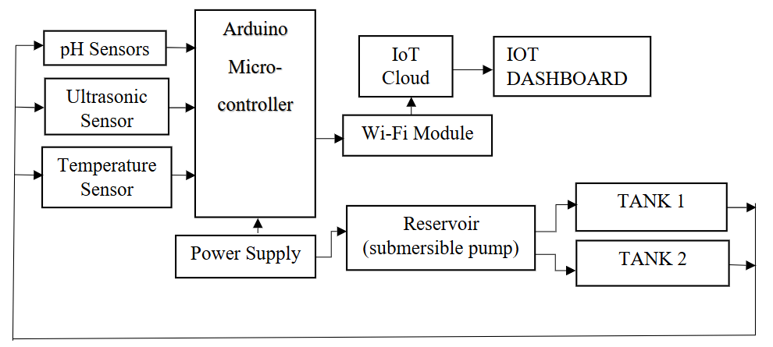

**Figure 4. 3** Block diagram of the project **[10]**.

The system consists of two tanks and a water reservoir connected, and a 5V DC pump system. Each tank is equipped with an ultrasonic sensor placed on top, which is responsible for monitoring the water level in the tank. When the water in the tank reaches the lowest level, the ultrasonic sensor will send a signal to the Arduino microcontroller to activate the pump, ensuring that water is pumped into the tank. Conversely, when the water reaches the highest level, the sensor will send a signal to turn off the pump, helping to prevent water overflow. The system operates fully automatically, ensuring effective management of the water level in the tanks.

A pH sensor is installed in the reservoir where water is pumped into the two tanks to assess safety for use. The pH value is displayed on the IoT dashboard, and if the pH is out of the neutral range (below 7 is acidic, above 7 is alkaline), the water will need to be filtered. The pH scale ranges from 0 to 14, with 7 being neutral, indicating a balance between acid and alkalinity **[10]**. Additionally, a temperature sensor is placed in the reservoir to measure the temperature of the water as it enters the tank, determining how hot or cold the water is.

The data collected from the sensor, including water level, pH, and temperature, is transmitted to the Cayenne myDevices IoT platform via a Wi-Fi module **[10]**. This platform allows for real-time analysis and visualization of values, helping users monitor and manage water quality effectively.

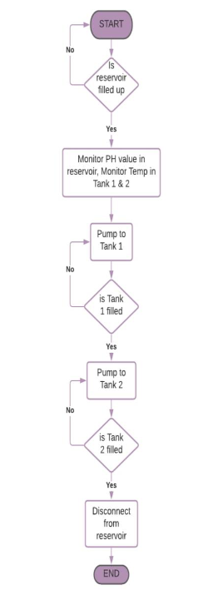Figure 4.4 is a flow chart of the system's operation.

**Figure 4. 4** Flow chart diagram of the project **[10]**.

#### Hardware.

These are the hardware devices as well as the final product developed in figure 4.5.

* Ph sensor
* Arduino mega
* Esp8266 wifi module
* Temperature sensor
* Ultrasonic sensor

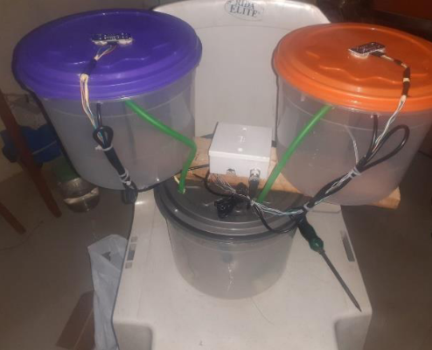

**Figure 4. 5** Image of the final project work **[10]**.

### Third article: Real-time Water Quality Monitoring and Notification System for Aquaculture [11]

This paper presents a water quality monitoring system that can automatically adjust four types of water quality parameters including temperature, potential hydrogen (pH) level, turbidity, and dissolved oxygen. The system uses Arduino Nano as the main controller, combined with NodeMCU (ESP8266) to transmit data via Firebase Realtime Database **[11]**. A mobile application is developed using React Native, supporting real-time value monitoring, receiving notifications when the indicators are out of standard, and providing appropriate action suggestions. The main purpose of the research is to develop a smart farm model using IoT to raise fish at high density in a closed system to be environmentally friendly and sustainable **[11]**.

#### Hardware design.

Key features include:

* Monitoring and reporting abnormal values.
* Customizing water quality thresholds.
* Displaying historical data in a visual graph.

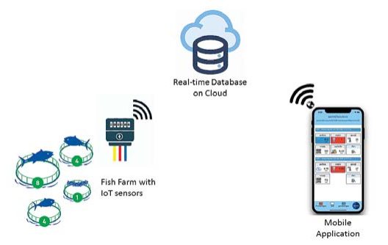Figure 4.6 below illustrates the conceptual framework and main components of the system

**Figure 4. 6** Conceptual Diagram of Water Quality Monitoring and Notification System **[11].**

Figure 4.7 shows the main components of the hardware system.

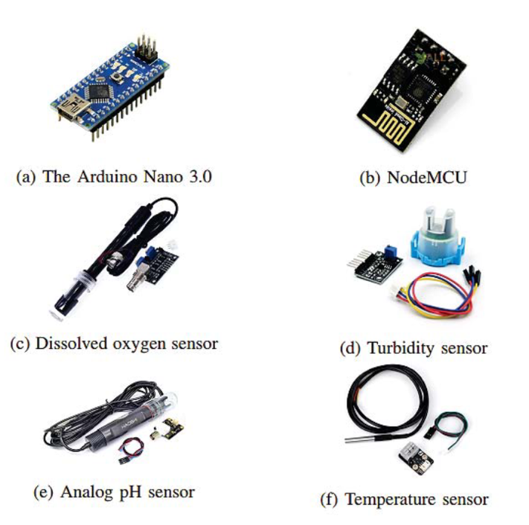

**Figure 4. 7** The major components of the system **[11]**.

## Proposed methodology for this senior project.

Through the study of related documents in section **4.1**, many water quality monitoring systems have been developed based on IoT technology. Most of them use sensors to measure important parameters such as temperature, pH, dissolved oxygen and turbidity, combined with connection modules to transmit data in real time or over the network. The study by Katole and colleagues(section **4.1.1**)used Arduino Mega, temperature, pH, turbidity sensors, and GSM module to collect, analyze water quality data and send SMS notifications to users. This system allows real-time monitoring and alerts when parameters exceed safety thresholds. Similarly, Ogundele Joshua’s research (section **4.1.2**) focused on monitoring water quality and water levels in tanks, combined with the Cayenne IoT platform to display data via an online dashboard. This research highlights the flexibility and integration of IoT in remote water monitoring, making it easy for users to check important indicators from anywhere. And Jomsuda Duangwongsa’s research (section **4.1.3**) successfully implemented a system using Arduino Nano, NodeMCU (ESP8266) and Firebase Realtime Database to monitor water in aquaculture ponds, providing information directly via a mobile application. These studies are important references for developing the method in my project.

Based on the results and techniques from the above studies, my project applies pH, temperature and turbidity sensors, connects to Arduino UNO, displays parameters on LCD screen and ESP8266 module to transmit data via WiFi to Blynk application and GSM module to users. The difference is the flexible combination of two data transmission methods (WiFi and 4G), allowing the system to operate even without WiFi connection. This not only saves costs but also ensures providing real-time data and warnings when water parameters exceed thresholds.

# METHODOLOGY

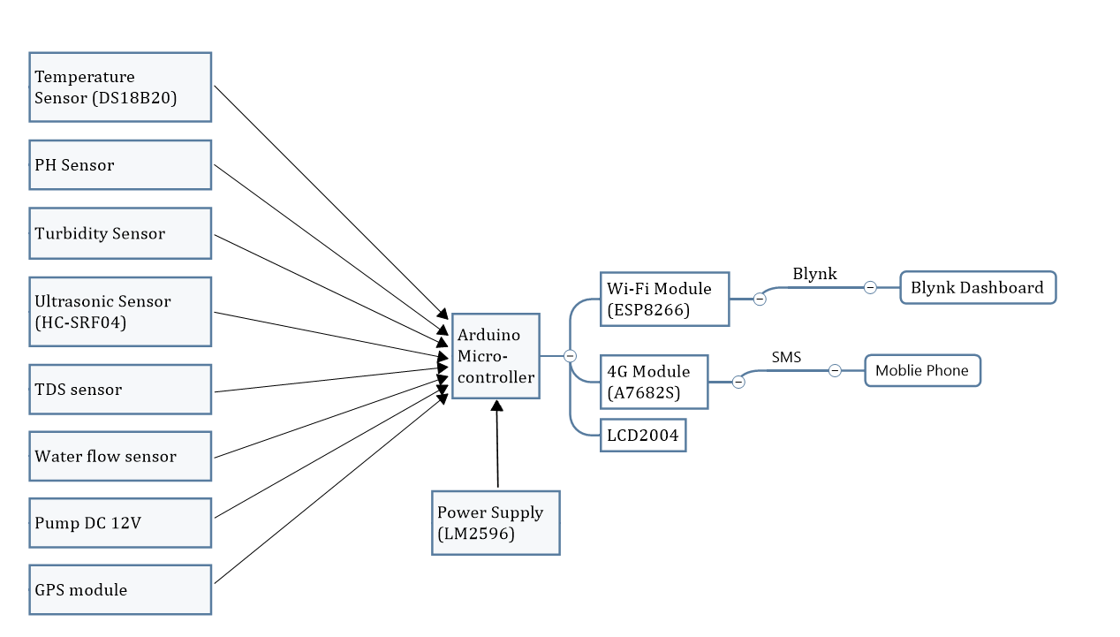Based on the goals and objectives in Chapter I and the analysis results from related studies in Chapter IV, the overall design of the water monitoring system is shown: Figure 5.1

**Figure 5. 1** Block diagram of the system.

The methods will be described in detail in this chapter. I will present three main steps:

1. Hardware design
2. Software design
3. Data collection

## Hardware design.

The components used in this system are explained below.

### Temperature sensor.

The Dallas temperature sensor shown in Figure 5.2 is a 1-wire programmable temperature sensor and measures temperature in the range of -55°C to +125°C with an accuracy of ±0.5°C **[9]**. The sensor has a durable, waterproof design, suitable for harsh environments such as chemical fluids or soil. The DS18B20 only needs one data pin of the microcontroller, in the system connected to pin 12 of Arduino UNO via 1-Wire protocol, Arduino collects temperature data from DS18B20 using the **OneWire.h** and 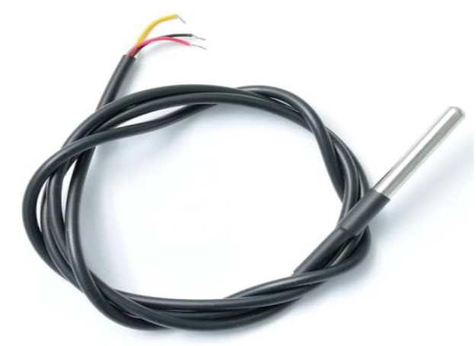**DallasTemperature.h** libraries.

**Figure 5. 2** Dallas temperature sensor (DS18B20).

### pH sensor.

pH (potential Hydrogen) is the acidity or alkalinity of water. The pH sensor module in figure 5.3 consists of pH sensor also called as pH probe and a signal conditioning board which gives an output which is proportional to the pH value and can be interfaced directly to any microcontroller **[11]**.

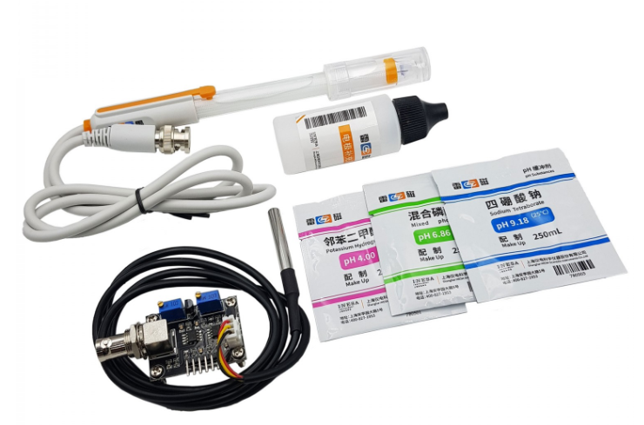

**Figure 5. 3** Analog PH sensor.

Technical parameters of pH sensor module E-201C bảng 5.1

**Table 5. 1** Technical parameters of pH sensor **[13].**

|  |  |  |
| --- | --- | --- |
| Numbers | Parameters | Values |
| 1 | Power supply | 5VDC |
| 2 | Working current | 5 ~ 10mA |
| 3 | Power consumption | <0.5W |
| 4 | Return signal | Analog |
| 5 | PH measurement range | 0 - 14 pH |
| 6 | Response time | ≤ 5 seconds |
| 7 | Stabilization time | ≤ 60 seconds |
| 8 | Accuracy | ±0.1 pH (at 25°C) |
| 9 | Working temperature range | 0°C – 60°C (best at 20°C) |
| 10 | Working humidity range | 0% – 95% (best at 60%) |
| 11 | Response speed | < 1 minute |
| 12 | Weight | 25g |

The analog signal is connected to the **A0** pin of Arduino UNO. pH value ranges from 0-14, with 0 – 6 as acidic and 8 – 14 as alkaline. Acidic water tastes sour, while alkaline water tastes bitter or soap **[12]**.

### Turbidity Sensor.

Turbidity is the darkness or opacity of water due to the presence of many microscopic particles in the water that are invisible to the naked eye, like smoke in the air **[9]**. The turbidity sensor in figure 5.4 can detect water quality by measuring the level of turbidity/opacity in the water. It can detect suspended particles in water by measuring the scattering rate and transmittance, which vary with the amount of total suspended solids in the water. As the total suspended solids increase, the turbidity of the liquid also increases. The scale used by this sensor is Nephelometric Turbidity Units (NTU). In this system, the turbidity sensor outputs an analog voltage that is proportional to the water’s turbidity level. The analog signal is connected to the **A1** pin of Arduino UNO, where it is read and 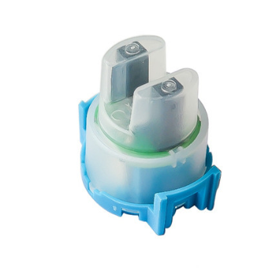processed.

**Figure 5. 4** Turbidity sensor.

### Ultrasonic sensor.

The ultrasonic sensor, as shown in figure X, measures distance by transmitting ultrasonic waves and receiving the reflected waves from the target surface. In this system, the sensor is used to monitor the water level in the tank, determining whether it is empty or full. The sensor works by calculating the time taken for the ultrasonic waves to travel to the water surface and return, which is then converted into distance using the speed of sound.

The ultrasonic sensor is connected to the Arduino UNO with two pins:

**Trigger** pin: Sends out the ultrasonic signal (Pin 4 of Arduino UNO)

**Echo** pin: Receives the reflected signal (Pin 5 of Arduino UNO)

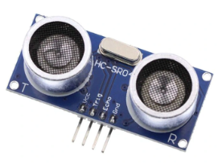

**Figure 5. 5** Ultrasonic sensor (HC-SRF04).

### Wifi module.

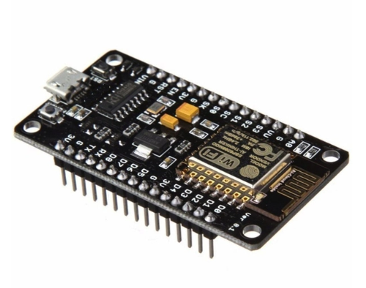The ESP8266 Wi-Fi Module, as shown in figure 5.6, is a self-contained system-on-chip (SoC) with an integrated TCP/IP protocol stack, enabling any microcontroller to connect to a Wi-Fi network. In this system, the ESP8266 is connected to the Arduino UNO via serial communication (TX/RX pins). Once the Internet connection is established, the module transmits data, including temperature, pH, and turbidity values, to the Blynk Cloud platform for remote monitoring.

**Figure 5. 6** The ESP8266 Wi-Fi module.

### GSM shield module.

The GSM shield module, as shown in figure 5.7, is used to provide cellular communication capabilities for the system. It allows Arduino UNO to send and receive SMS alerts using the GSM network. In this system, SIM800L is used to connect to Arduino UNO via serial communication (TX/RX pin).

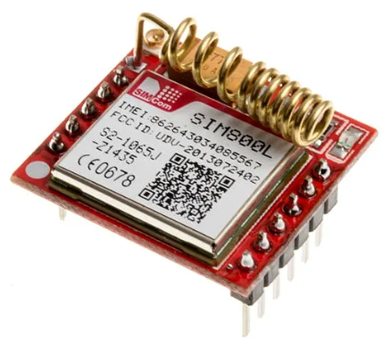

**Figure 5. 7** SIM800L.

When the measured parameters such as temperature, pH or turbidity exceed the pre-defined threshold value, the GSM module will send an SMS alert to a designated phone number, ensuring that the user receives timely warnings about abnormal water quality conditions.

The GSM shield works with the current SIM card only integrated with Viettel network. The module requires a stable power supply of 4.0V to 4.2V for normal operation, which is achieved through the DC-DC converter in the circuit.

### Power Supply.

The power supply module provides the necessary voltage and current to operate the entire system. In this system, a DC-DC converter (LM2596) in figure 5.8 is used to step down the voltage from a 12V power source to 5V, ensuring compatibility with the components.

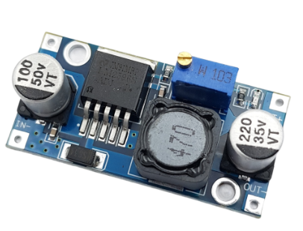

**Figure 5. 8** DC Voltage Reduction Circuit LM2596.

## Software design.

### Drawing the schematic.

From the components in section 5.1, figure 5.9 is the circuit diagram of the system drawn on proteus software.

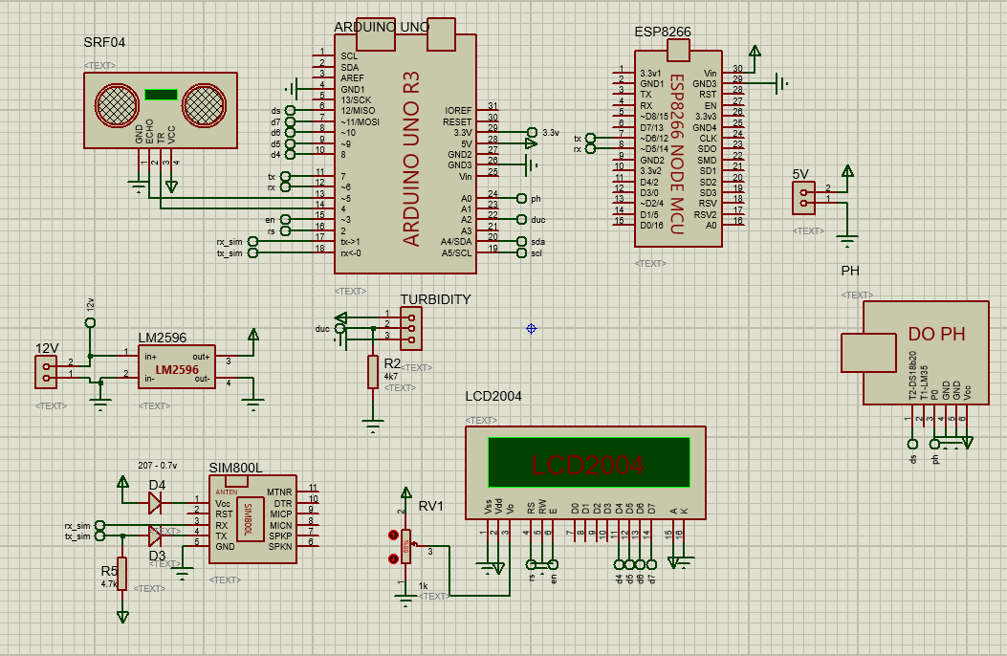

**Figure 5. 9** Schematic of the system on Proteus software.

### Blynk.

Blynk is a platform that lets users easily create interfaces for controlling and monitoring hardware projects using iOS and Android devices. After downloading the Blynk applications, the user may design a project dashboard by arranging buttons, sliders, graphs, and other widgets on the screen. The widgets allow the user to turn on and off pins and show sensor data.

The Blynk App displays real-time data from the system’s sensors, including:

* Temperature from the DS18B20 sensor.
* pH levels from the pH sensor.
* Turbidity (water clarity) from the turbidity sensor.
* Water level from the ultrasonic sensor (SRF04).

These values are sent from the ESP8266 Wi-Fi Module to the Blynk Cloud and then retrieved by the app for live display.

### Programming for all systems.

Figure 5.10 shows the flowchart of the IoT applications on water quality monitoring system. First, the user needs to establish a connection between the microcontroller (Arduino UNO), sensors, GSM module and Wi-Fi network via a hotspot or Wi-Fi connection. Once the connection is established, the sensors will measure water quality parameters, including:

* Temperature sensor (DS18B20): Measures water temperature.
* pH sensor: Measures water pH.
* Turbidity sensor: Measures water transparency.
* Ultrasonic sensor (SRF04): Measures water level in the tank.

The measured data from the sensors is converted into digital signals and sent to Arduino UNO for processing. The parameters are then:

* Displayed on the LCD screen for direct on-site monitoring.
* Transmit to ESP8266 Wi-Fi module and send to Blynk Cloud, where Blynk application on smartphone will receive and display the measured values.

If the parameters exceed the pre-set threshold:

* An alarm will be triggered on Blynk App (red LED turns on).
* At the same time, SMS messages will be sent via GSM module (SIM800L) to the pre-set phone number to notify the abnormal situation.

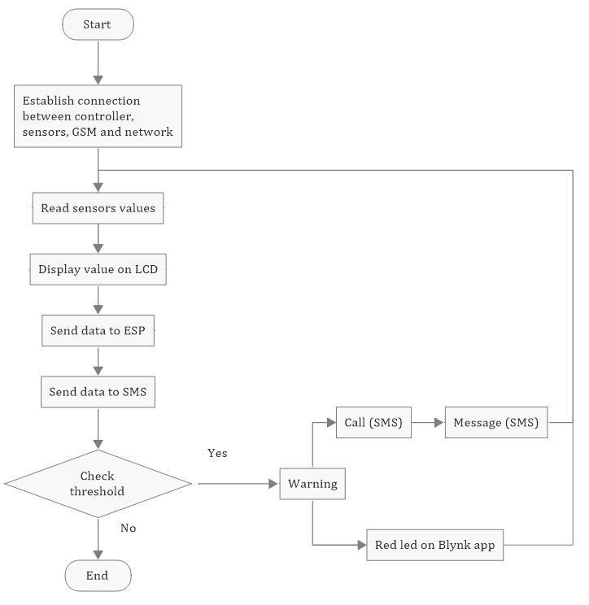

**Figure 5. 10** The Flowchart of IoT Water Monitoring System.

# RESULTS

In this chapter, we will show the results of this project.

## Hardware design.

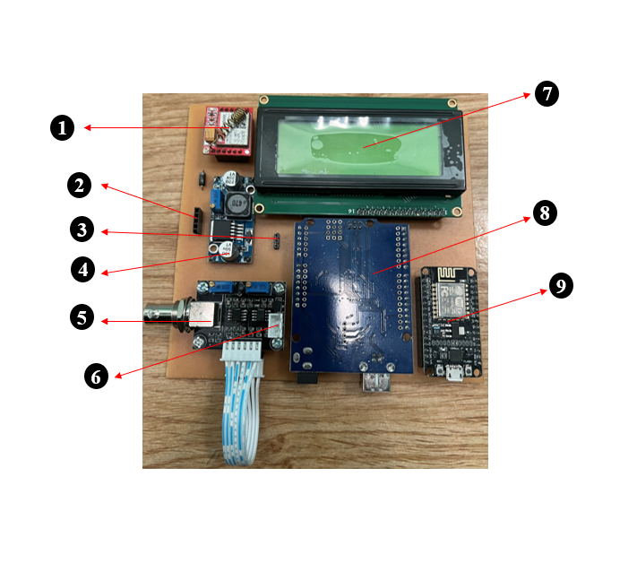Figure 6.1 shows the hardware system of the IoT water quality monitoring project, including main components such as sensors and the placement of components detailed on the circuit board below.

**Figure 6. 1**. Hardware system.

1. GSM shield module (SIM800L).
2. Ultrasonic sensor (HC-SRF04).
3. DC-DC converter (LM2596).
4. Turbidity sensor.
5. pH sensor.
6. Temperature sensor (DS18B20).
7. LCD display.
8. Arduino UNO R3.
9. Wifi module (ESP8266).

## Software design.

### Blynk app.

Figure 6.2 shows the Blynk application interface on smartphone, which displays the parameters measured from the system such as pH, temperature, turbidity, and water level. These values ​​are updated in real time via Wi-Fi connection. In addition, alerts are also triggered when parameters exceed safe thresholds, indicated by a red LED on the dashboard.

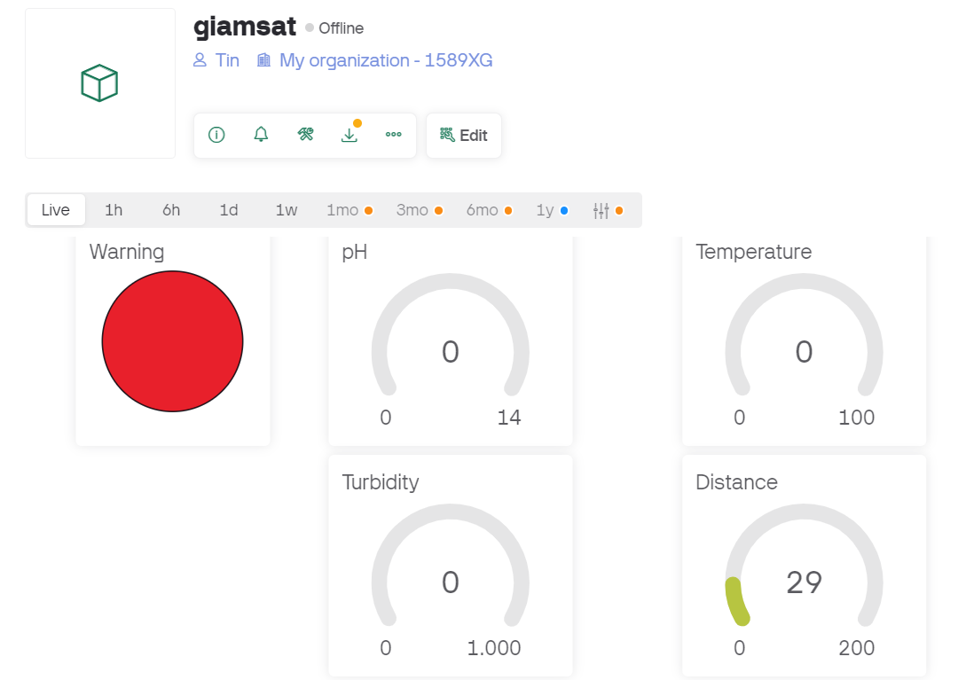

**Figure 6. 2** Blynk application interface on smartphone.

### Prototype product.

Figure 6.3 is the completed product with all sensors and components.

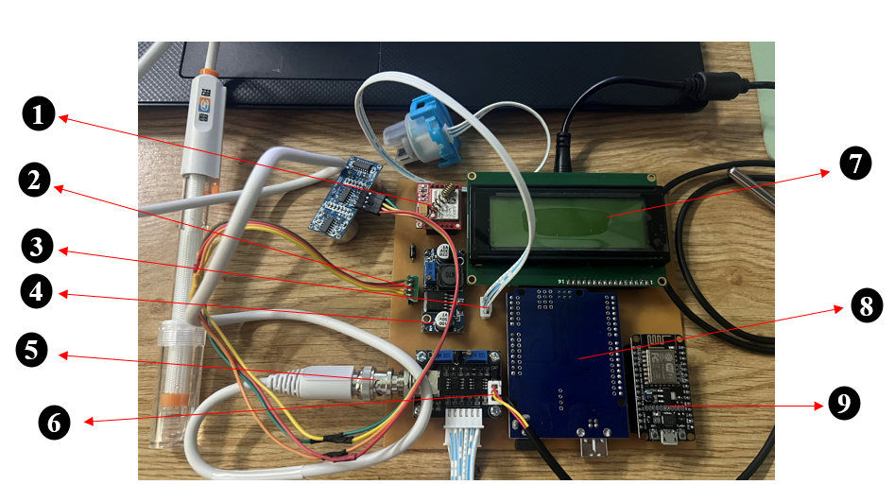

**Figure 6. 3** Entire system

1. GSM shield module (SIM800L).
2. Ultrasonic sensor (HC-SRF04).
3. DC-DC converter (LM2596).
4. Turbidity sensor.
5. pH sensor.
6. Temperature sensor (DS18B20).
7. LCD display.
8. Arduino UNO R3.
9. Wifi module (ESP8266).

### System boot.

When the system starts, the LCD screen will display the message "INIT SIM... PLEASE WAIT..." (Figure 6.4) to signal that the system is checking and initializing the connection with the SIM800L module.

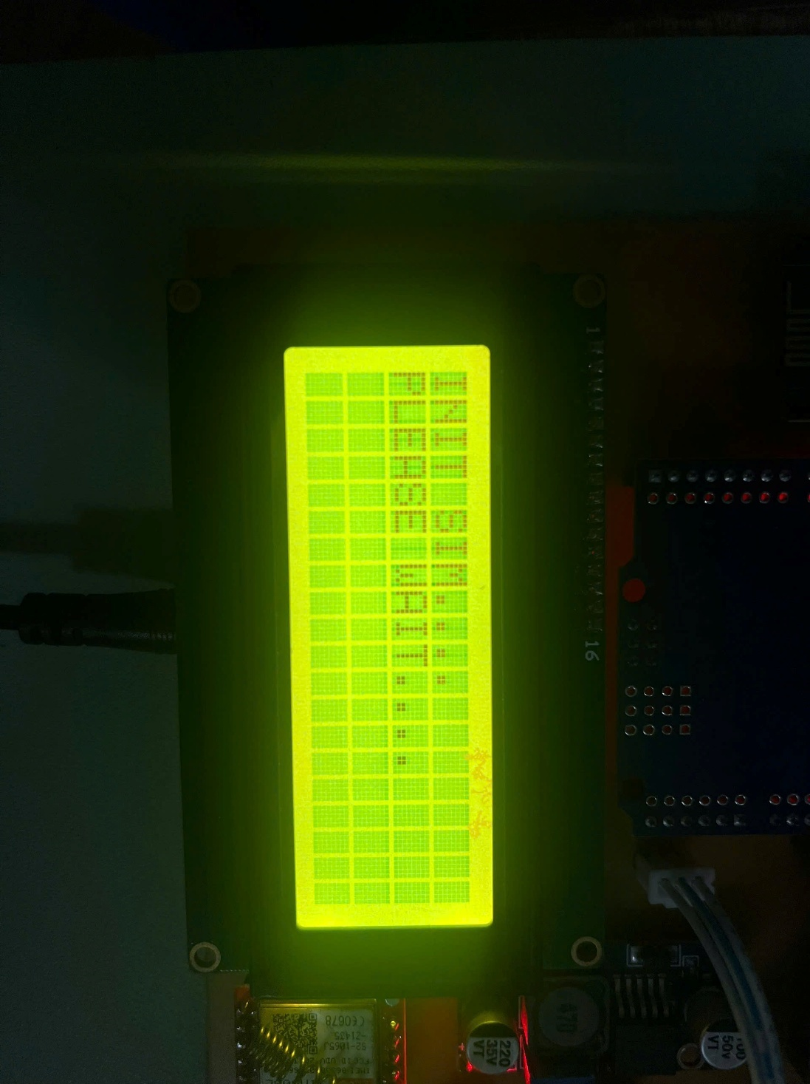

**Figure 6. 4** LCD display.

If the connection is successful, the light on the SIM800L module will flash slowly (Figure 6.5)

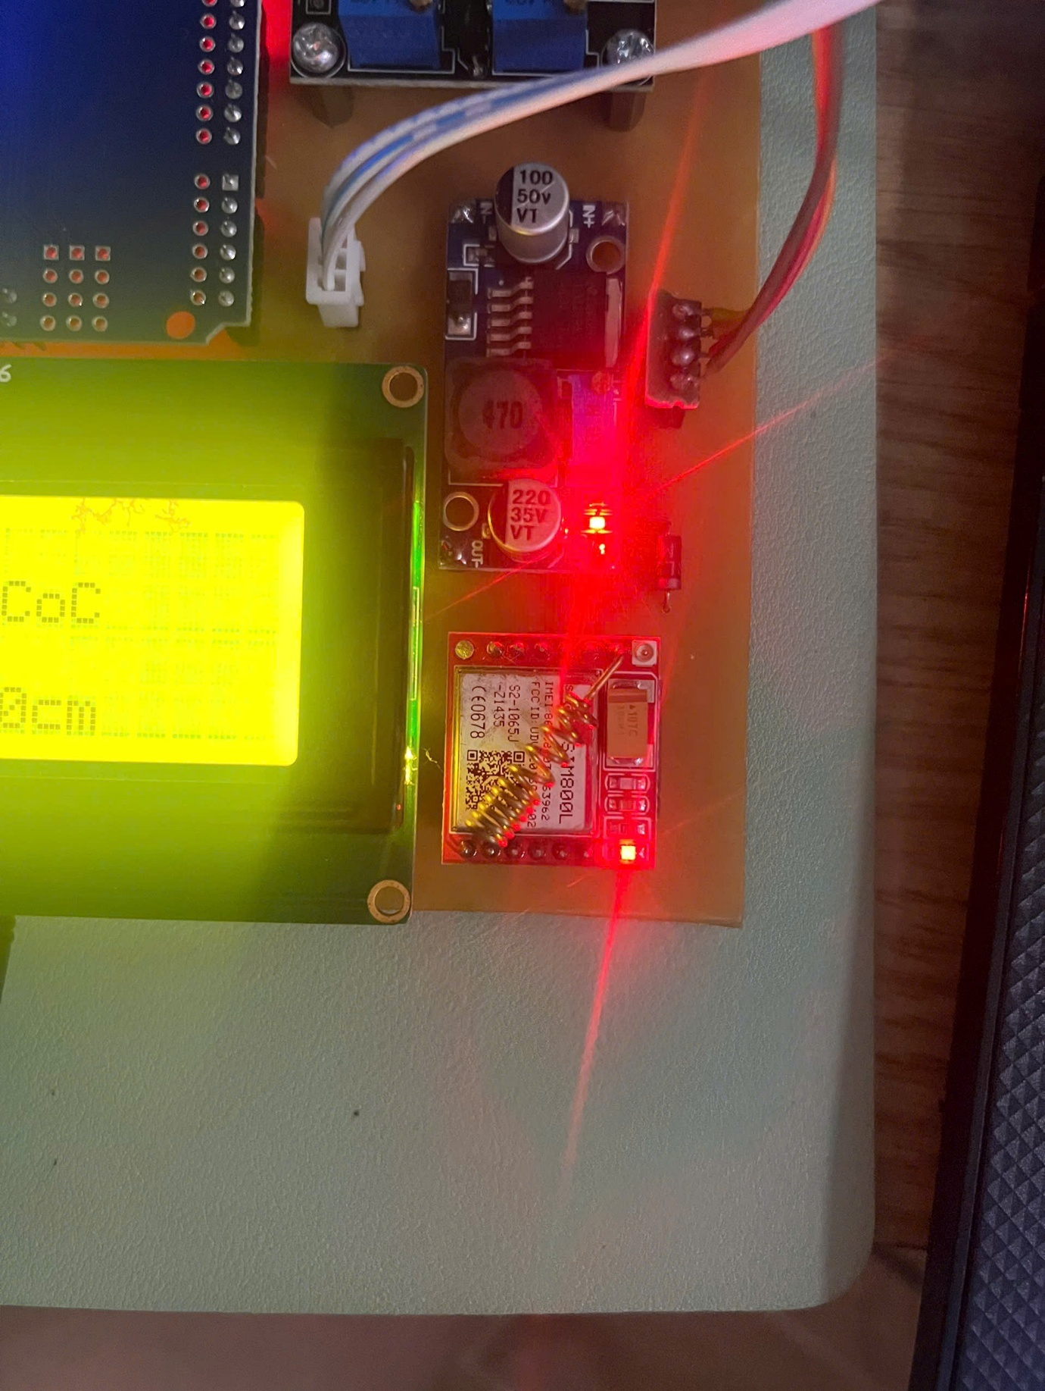

**Figure 6. 5** SIM800L module in operating state.

and a message “START SUCCESSFUL” will be sent to the predetermined phone number, along with the parameters measured from the sensors at that time (Figure 6.6).

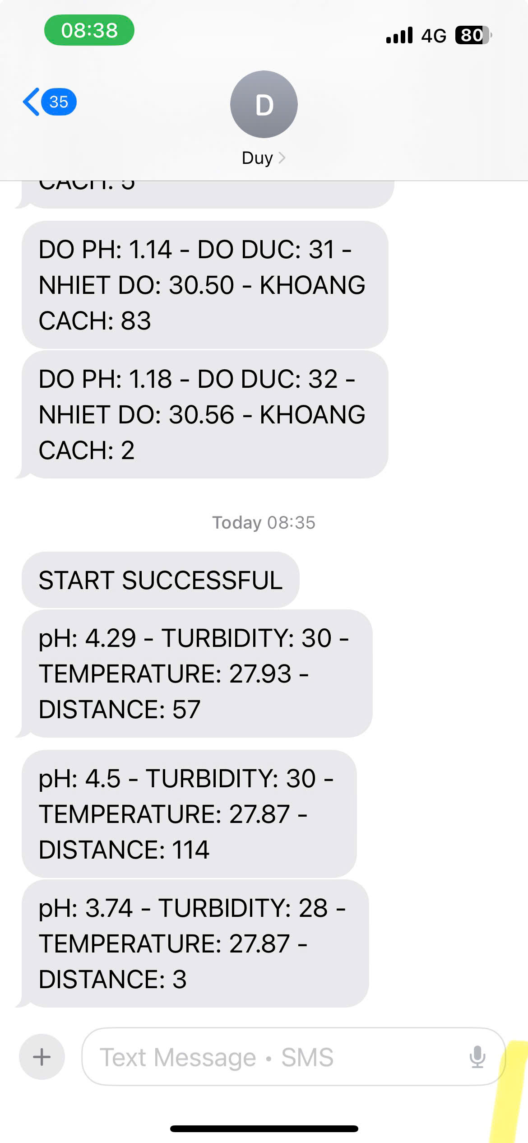

**Figure 6. 6** SIM connection success notification and sensor data.

For Wi-Fi network connection, the ESP32 module plays a role in ensuring the connection between the system and the Blynk application. When the ESP32 module successfully connects to the Wi-Fi network and the Blynk application on the phone, the light on the module will light up, indicating the operating status (Figure 6.7).

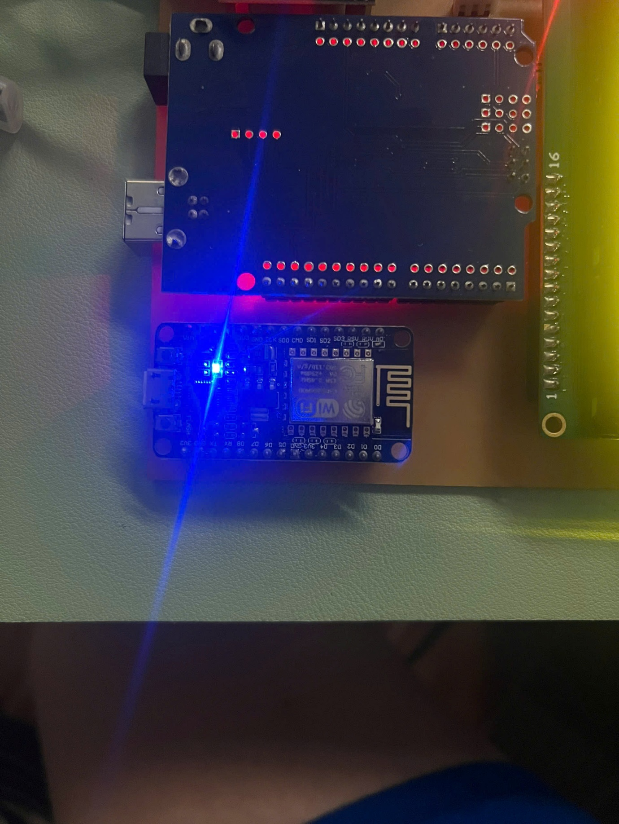

**Figure 6. 7** ESP32 module successfully connects to the Wi-Fi network.

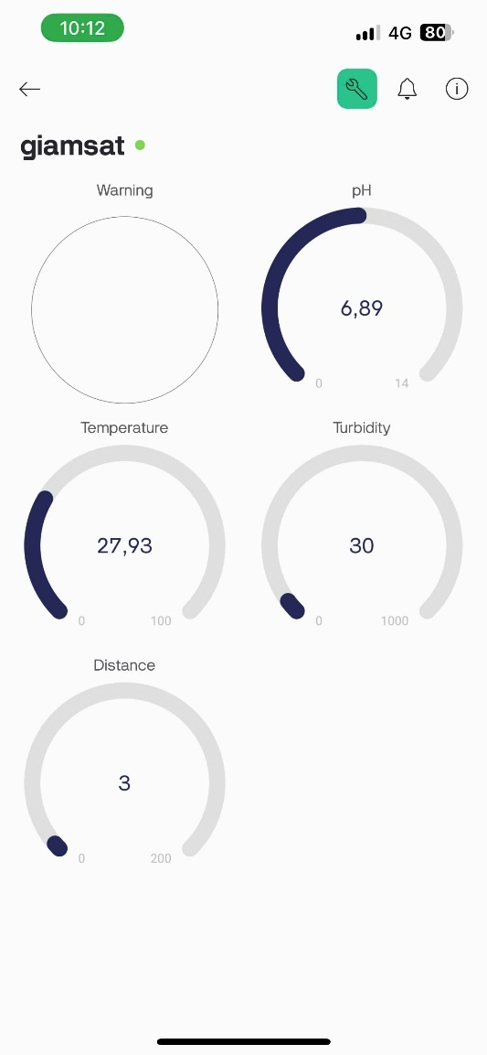At this time, the Blynk application will start receiving and directly displaying parameters from the sensors, including pH, temperature, turbidity, and water level (Figure 6.8).

**Figure 6. 8** Blynk application interface displaying sensor parameters.

## Evaluate the system performance in different environments.

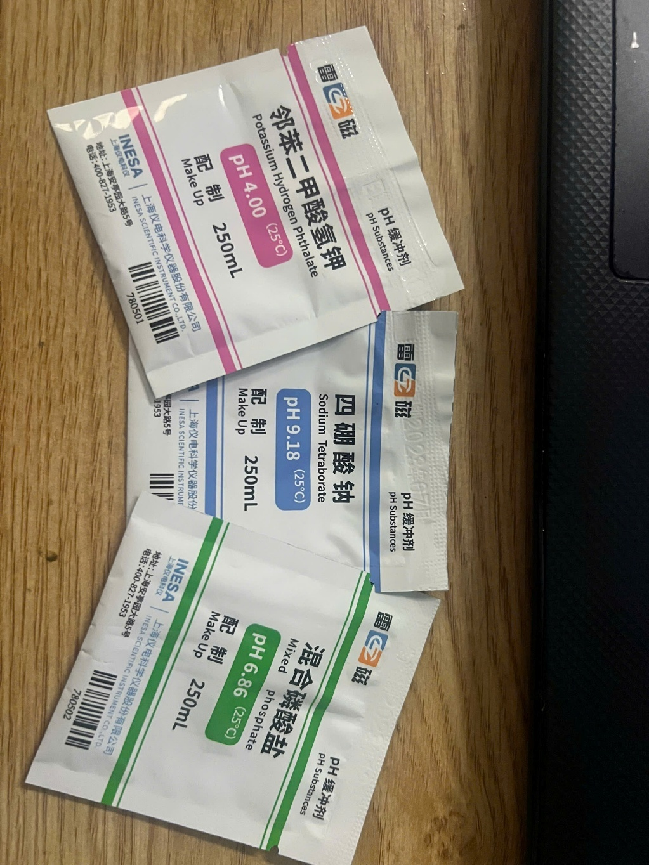The water quality monitoring system was tested in different environments to evaluate the accuracy of the sensors measuring pH, temperature, turbidity and water level. Among the measured parameters, pH is the most important, to create a neutral, acidic, basic water environment. I used a pH correcting powder (Figure 6.9).

**Figure 6. 9** pH correction package.

With pH parameters provided by the manufacturer as shown in table 6.1

**Table 6. 1** pH correction package specifications

|  |  |  |  |
| --- | --- | --- | --- |
| **oC** | **pH4.01** | **pH6.86** | **pH9.18** |
| 10 | 4.00 | 6.92 | 9.33 |
| 15 | 4.00 | 6.90 | 9.28 |
| 20 | 4.00 | 6.88 | 9.23 |
| 25 | 4.01 | 6.86 | 9.18 |
| 30 | 4.01 | 6.85 | 9.14 |
| 35 | 4.02 | 6.84 | 9.10 |
| 40 | 4.03 | 6.84 | 9.07 |
| 45 | 4.04 | 6.83 | 9.04 |
| 50 | 4.06 | 6.83 | 9.02 |

To check the accuracy of the system after calibration, I conducted tests in three specific cases, corresponding to three different environments:

Acidic environment: pH about 4.

Neutral environment: pH about 6.

Basic environment: pH about 9.

### Case 1: Acidic environment: pH about 4.

In the first test, water with a low pH (around 4) was tested. The system measured a value of 4.07, which matched the results from the litmus test, confirming the accuracy of the sensor. Illustrative image of the test:

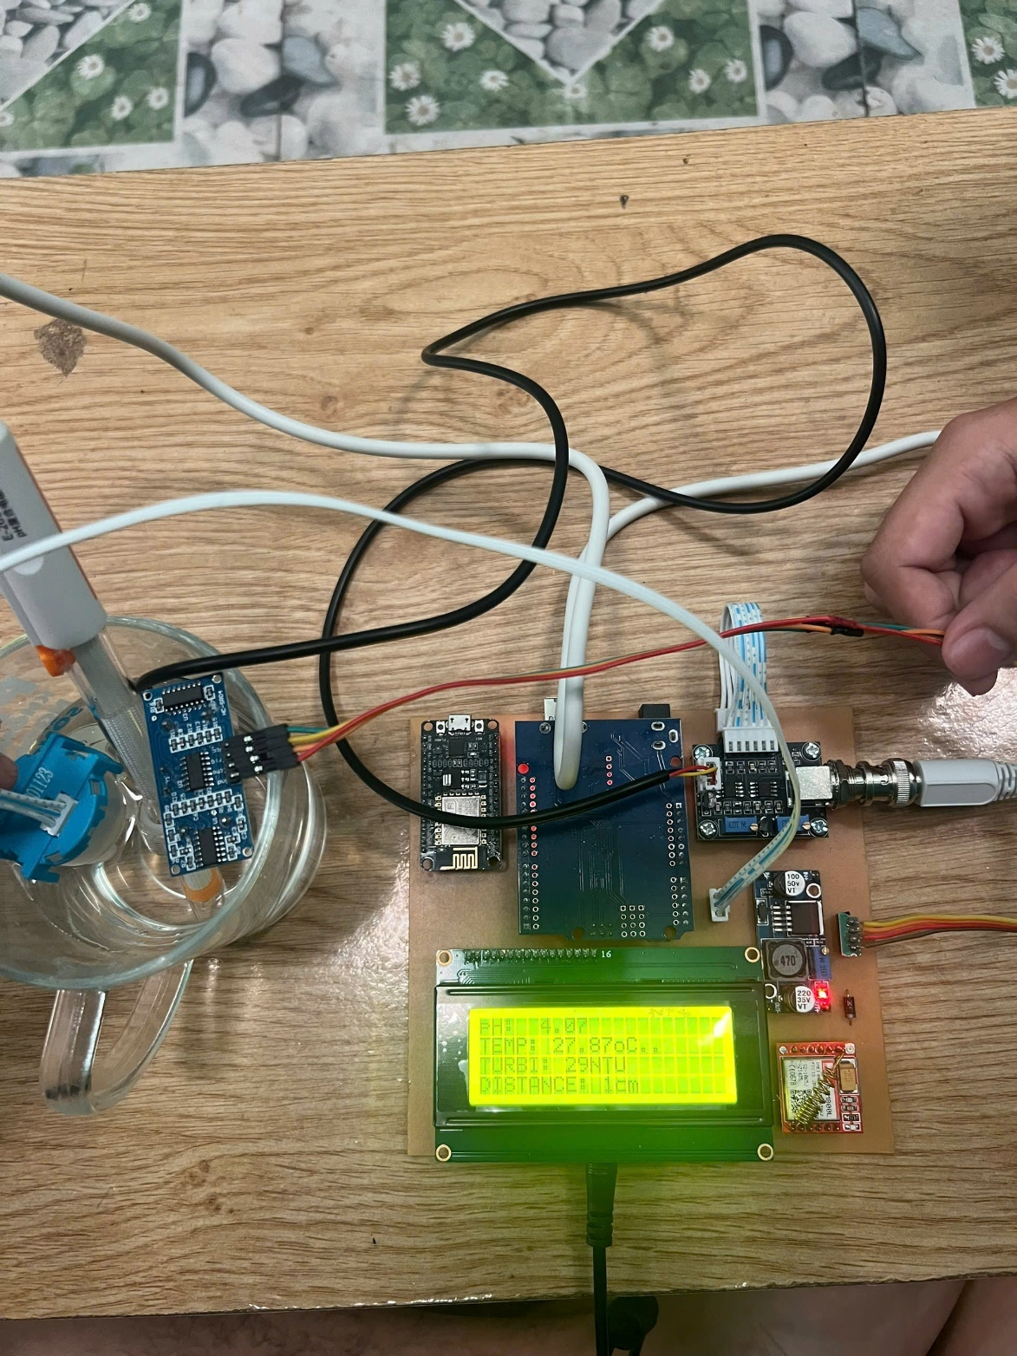

**Figure 6. 10** Hardware system when operating with low pH water samples.

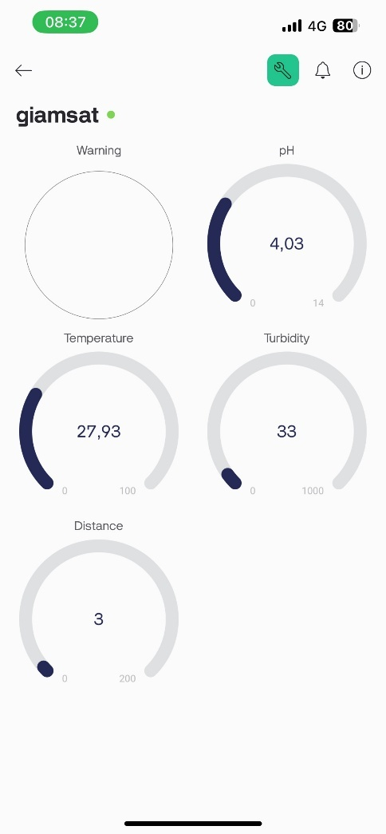

**Figure 6. 11** Blynk interface shows pH measurement result is 4.03 along with other indicators

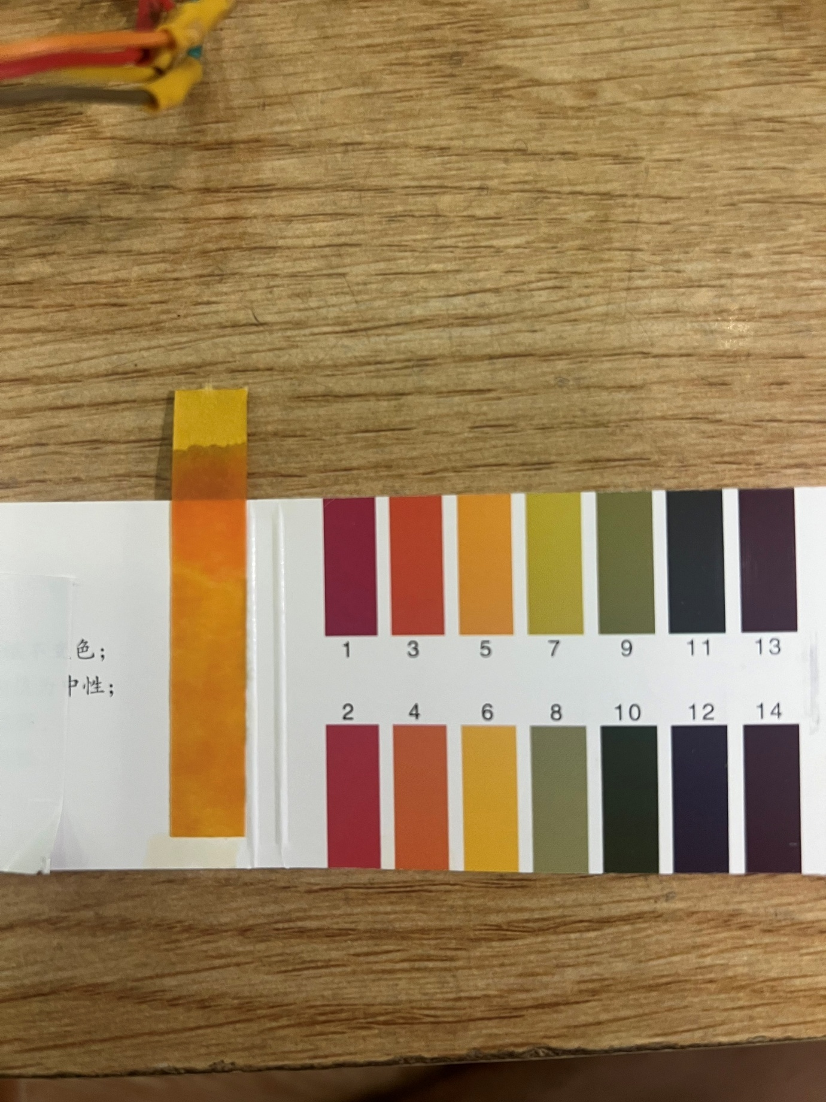

**Figure 6. 12** The litmus test results showed that the pH was at 4.

### Case 2: Neutral environment: pH about 6.

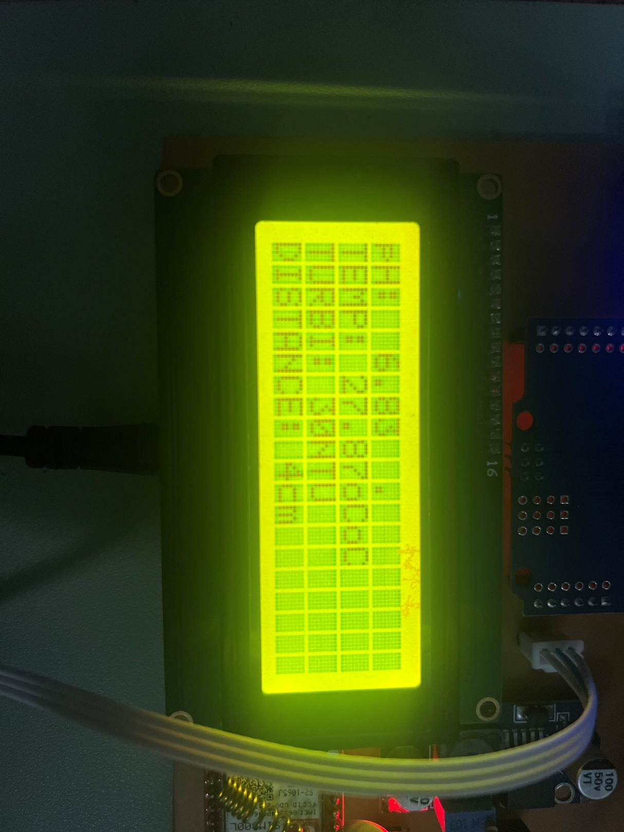In the second case, water with a neutral pH (around 6.) was measured and the value returned from the system was 6.83, which is close to the litmus test result, confirming the accuracy of the sensor. Illustrative image of the test

**Figure 6. 13** Hardware system when operating with pH = 6.83 water samples.

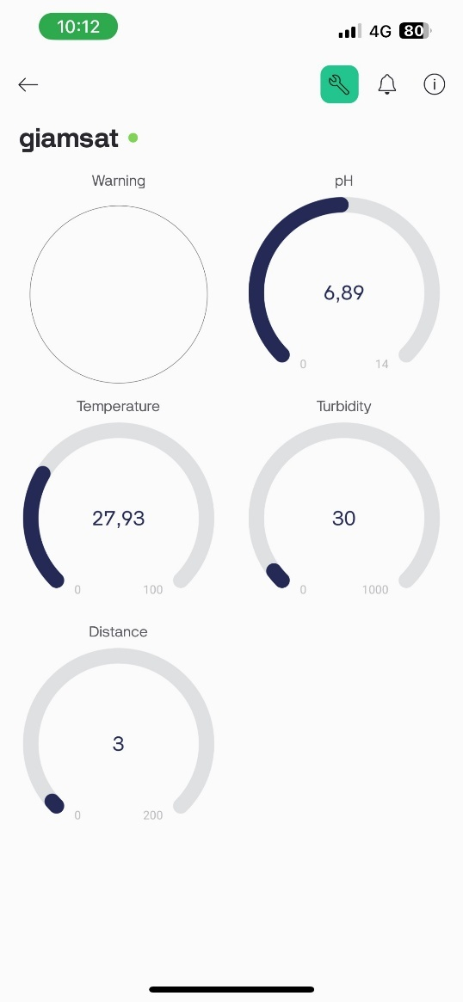

**Figure 6. 14** Blynk interface shows pH measurement result is 6.83 along with other indicators

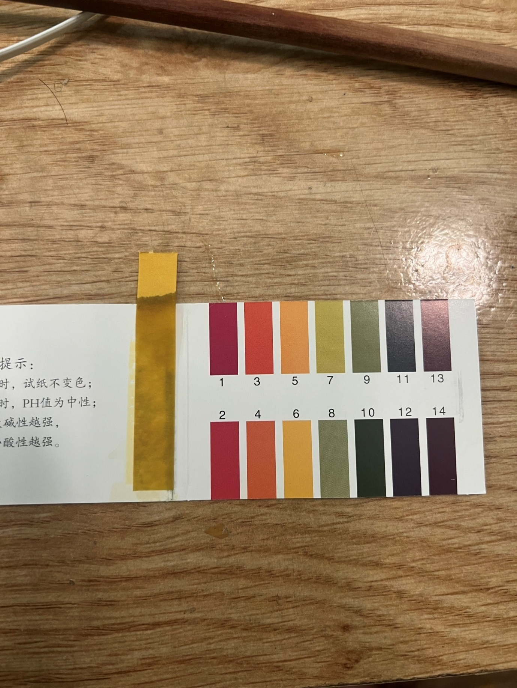

**Figure 6. 15** The litmus test results showed that the pH was at 6.

### Case 3: Basic environment: pH about 9.

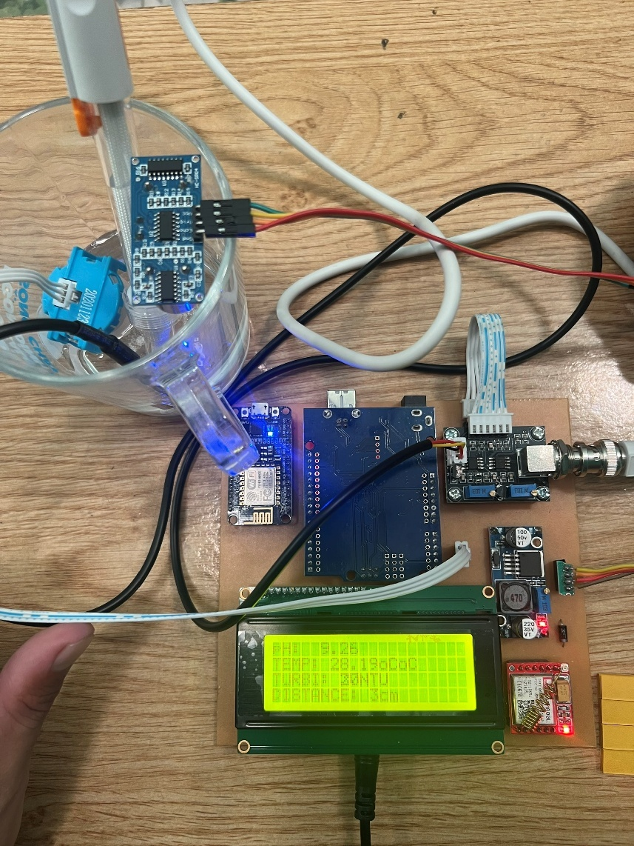In the first case, water with a high pH (above 9) was measured and the value returned from the system was 9.26, which is close to the litmus test result. Illustrative image of the test:

**Figure 6. 16** Hardware system when operating with high pH water samples.

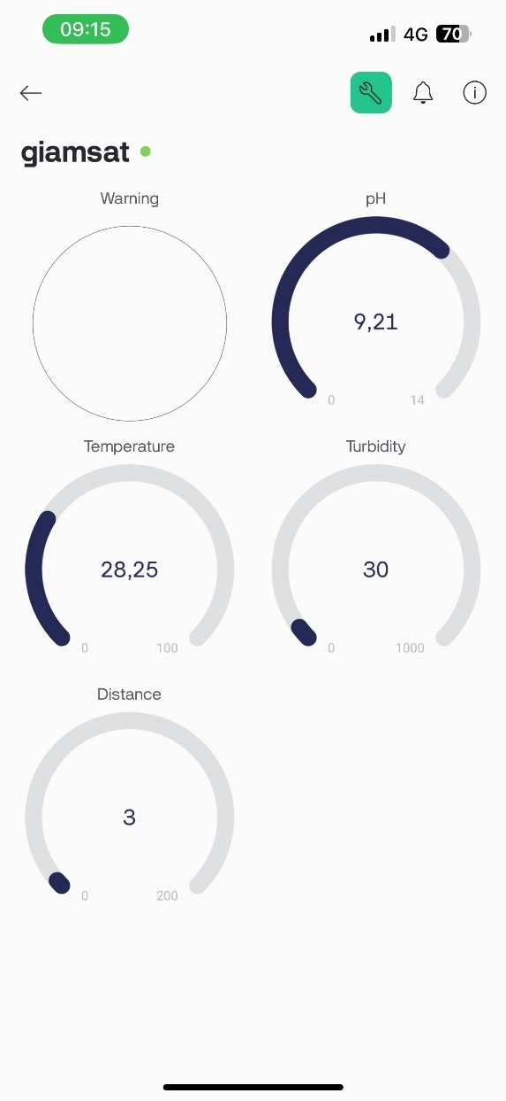

**Figure 6. 17** Blynk interface shows pH measurement result is 9.21 along with other indicators.

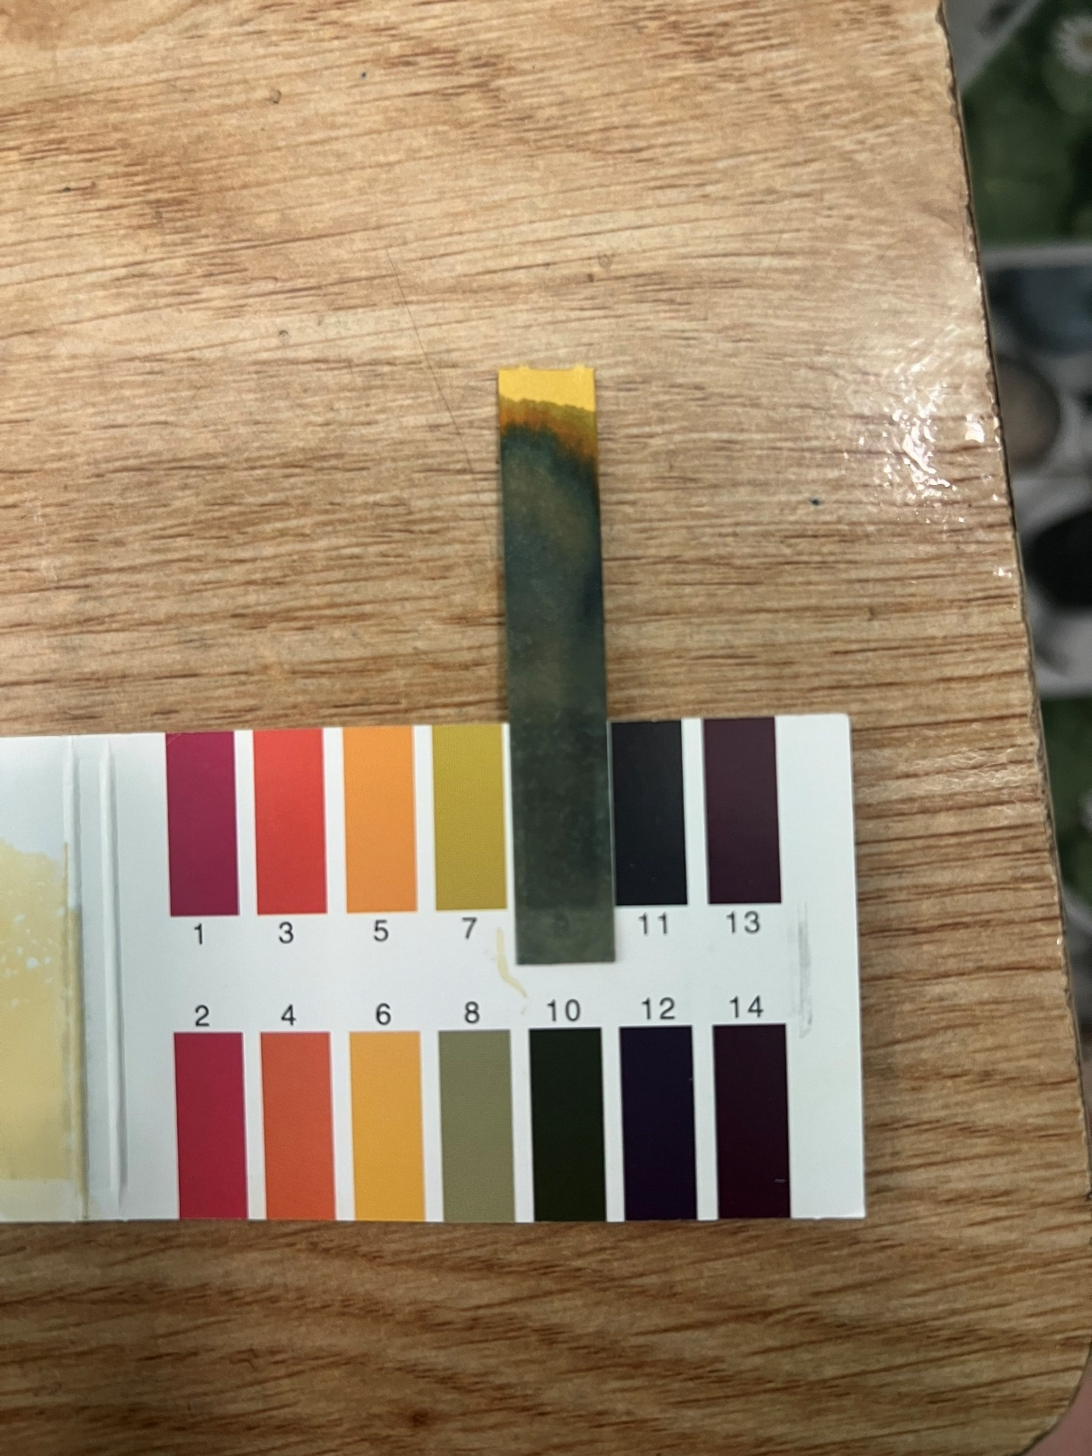

**Figure 6. 18** The litmus test results showed that the pH was at 10.

### Conclusion

These tests demonstrated the stability and accuracy of the system in measuring water quality indicators, especially pH values.

# CONCLUSIONS AND FUTURE WORK

## Conclusions.

During this senior project, I have gained extensive knowledge and practical experience in developing an IoT-based water quality monitoring system. This includes learning about integrating sensors such as DS18B20 (temperature sensor), pH sensor, turbidity sensor, and ultrasonic sensor with Arduino UNO microcontroller. We also developed skills in using ESP8266 and GSM module for wireless communication and data transmission.

Furthermore, this project also provided me with practical experience in circuit design, as well as practical techniques in assembling and testing hardware systems. I have also improved my skills in working with Blynk IoT platform to create a user-friendly interface for remote monitoring and management.

Although the current system is stable, there are still parts that need to be optimized and improved. In the future, I will improve the efficiency of the system, expand the monitoring capabilities by adding more sensors, and improve the reliability of communication channels to ensure seamless operation in various environments.

## Future work.

An IoT-based water quality monitoring system has been successfully developed to measure parameters such as temperature, pH, turbidity, and water level. While the current system meets the main goals of real-time monitoring and remote access, there are still limitations that need to be addressed. For example, the system’s reliance on Wi-Fi to transmit data to the cloud can be problematic in areas with unstable Internet connections. The accuracy of some sensors could be further optimized to be able to identify clean, polluted, or highly polluted water.

In the future, the team plans to improve the system by integrating additional sensors, such as dissolved oxygen and salinity sensors, to provide a more comprehensive assessment of water quality. Another potential improvement involves applying AI-based analytics to predict water quality and provide proactive alerts, ensuring timely intervention.​

# REFERENCES

[1]. https://doctorhouses.com/tam-quan-trong-cua-nuoc-va-giai-phap-cuu-nguon-nuoc-sach.html

[2]. https://vtv.vn/xa-hoi/nguon-nuoc-o-nhiem-co-the-gay-ton-that-toi-35-gdp-moi-nam-20240329195002844.htm

[3]. https://www.usgs.gov/special-topics/water-science-school/science/vong-doi-cua-nuoc-water-cycle-vietnamese

[4]. Ogundele Joshua, Francis Enejo Idachaba, Onyinyechi Steve-Essi, “Design and Implementation of a Smart Water Monitoring System (IoT) Using Arduino Microcontroller”, College of Engineering, College of Engineering, Covenant University, Covenant University, 2022

[5]. S. Kavi Priya, G. Shenbagalakshmi, and T. Revathi, "Design of smart sensors for real-time drinking water quality monitoring and contamination detection in water distributed mains", International Journal of Engineering & Technology, Vol. 7, pp42-51. 2018

[6]. N. Andre Cloete, R. Malekian and L. Nair, "Design of Smart Sensors for Real-Time Water Quality Monitoring”, Journal of IEEE Access, Vol. 13, No. 9, September 2014.

[7]. P. B. Bokingkito Jr and O.E. Llantos, "Design and Implementation of Real-Time Mobile-based Water Temperature Monitoring System", Procedia Computer Science, Vol.123, pp. 698-705, 2017.

[8]. M. Pule, A. Yahya and J. Chuma, "Wireless sensor networks: A survey on monitoring water quality. Journal of Applied Research and Technology", Vol. 15, 562-570, January 2018.

[9]. Kavita Katole, Yashoj Narnaware, Banshikha Biswas, Dimpal Patle, “Design & Implementation of Water Quality Monitoring & Notification  
System”, International Research Journal of Engineering and Technology (IRJET), 2019.

[10]. Ogundele Joshua Iyanuoluwa, Steve-Essi Onyiyechi, Francis Idachaba, “Design and Implementation of a Smart Water Monitoring System (IoT) Using  
Arduino Microcontroller”, College of Engineering, Covenant University, 2022.

[11]. Jomsuda Duangwongsa, Thepparath Ungsethaphand, Pradchayaporn Akaboot, Supakit Khamjai, Syan Unankard, “Real-time Water Quality Monitoring and  
Notification System for Aquaculture”, The 6th International Conference on Digital Arts, Media and Technology (DAMT) and 4th ECTI Northern Section Conference on Electrical, Electronics, Computer and Telecommunications Engineering, 2021.

[12]. M. P. P. Sithole, N. I. Nwulu, E. M. Dogo, "Development of a Wireless Sensor Network Based Water Quality Monitoring and Notification System", Department of Electrical and Electronic Engineering Science, University of Johannesburg, South Africa, 2019.

[13]. Mohd Sallehin Mohd Kassim, Mohd Rifqi Rozman, Aznida Abu Bakar Sajak, Rula Alrawashdeh, "IoT Water Quality Monitoring for Smart City”, Article in International Journal of Advanced Trends in Computer Science and Engineering, September 2020.